npx create-next-app@latest next-firebase-jsx
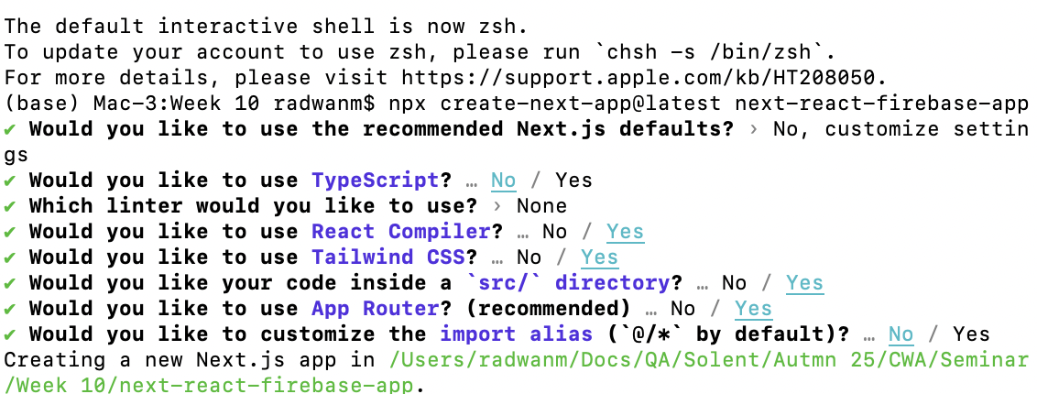

cd next-firebase-jsx

npm run dev

npm install firebase

